TABLE OF CONTENTS

1) Introduction 2
2) Unpacking the Ares 2
3) Installing the Ares in your system 3
4) Setting the Operational Parameters 4
5) High Output MM/MC Cartridge Setup 6
6) Medium Output Cartridge Setup 7
8) Low Output Cartridge Setup 8
9) Operation of the Ares 9
10) Troubleshooting 9
11) Specifications____________________________10
12) Warranty Information______________________11

INTRODUCTION
Congratulations on your purchase decision! We at Rogue Audio truly believe that our equipment provides the “smartest” value in high-end audio. If you have never owned a vacuum tube phono preamp you will be thrilled by the silky-smooth sound and incredible detail that only tubes can provide. And with the Ares phono preamp, you can be sure that you are getting the very best in tube amplification. We at Rogue Audio are extremely proud of our products and want you to enjoy them to their fullest potential. So please, take the time to read through this short manual so that you can be confident that you have set up your phono section properly.
Unpacking THE Ares Phono preamplifier
Tools required: none
WARNING - This preamplifier uses voltages that could cause injury or death. Never open the preamplifier while it is plugged in, and always wait at least one hour after turning the unit off to unplug and open the unit. Lethal voltages can remain in the electronics after the unit is unplugged.
Your Ares phono preamp has been painstakingly inspected for cosmetic flaws during and after assembly. After unpacking the Ares be sure to save the packing materials. The packing materials and box have been carefully designed to protect your valuable equipment during shipping so if it ever needs to be shipped again, you will want to have the packing material available.

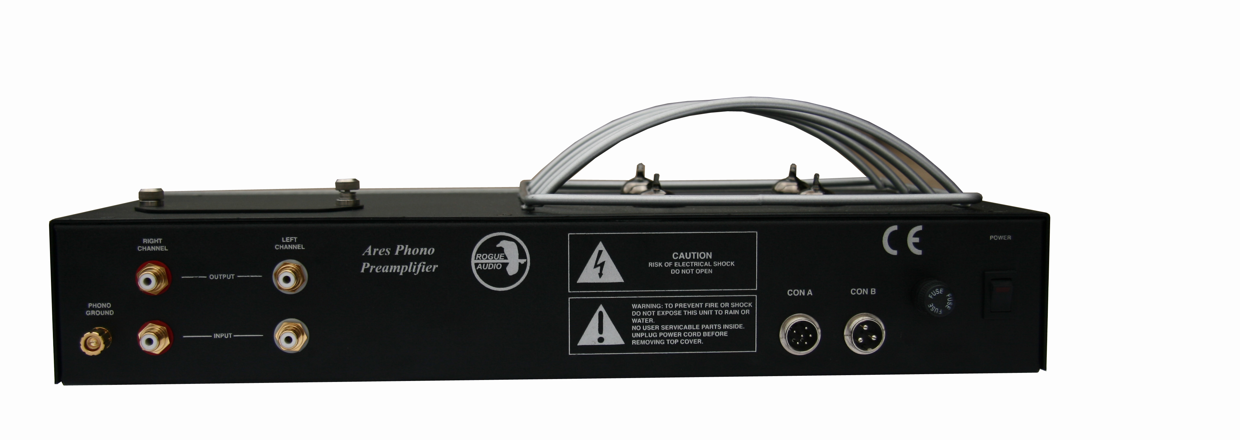

Figure 1

INSTALLATION OF THE ARES

Connecting the Power Supply to the Preamplifier
The Ares phono preamp has an outboard power supply (see figure 2) containing a toroidal transformer that is placed in a separate box to lower the noise floor of the unit. If possible, the smaller power supply chassis should be placed at least a foot or two away from the main unit in order to obtain quietest operation. There are two “umbilical” cables (Con A and Con B) that connect the power supply to the main chassis. Never connect or disconnect these two cables while the power supply is plugged into the wall outlet. Doing so could damage the phono preamp. Always unplug the IEC power cable before connecting or disconnecting the power supply connections.

Warning – Never disconnect power supply cables while the power supply is plugged into a power outlet.

When moving the preamp always turn off the power, wait 15 minutes and then unplug the preamp from the power outlet before disconnecting the power supply cables.
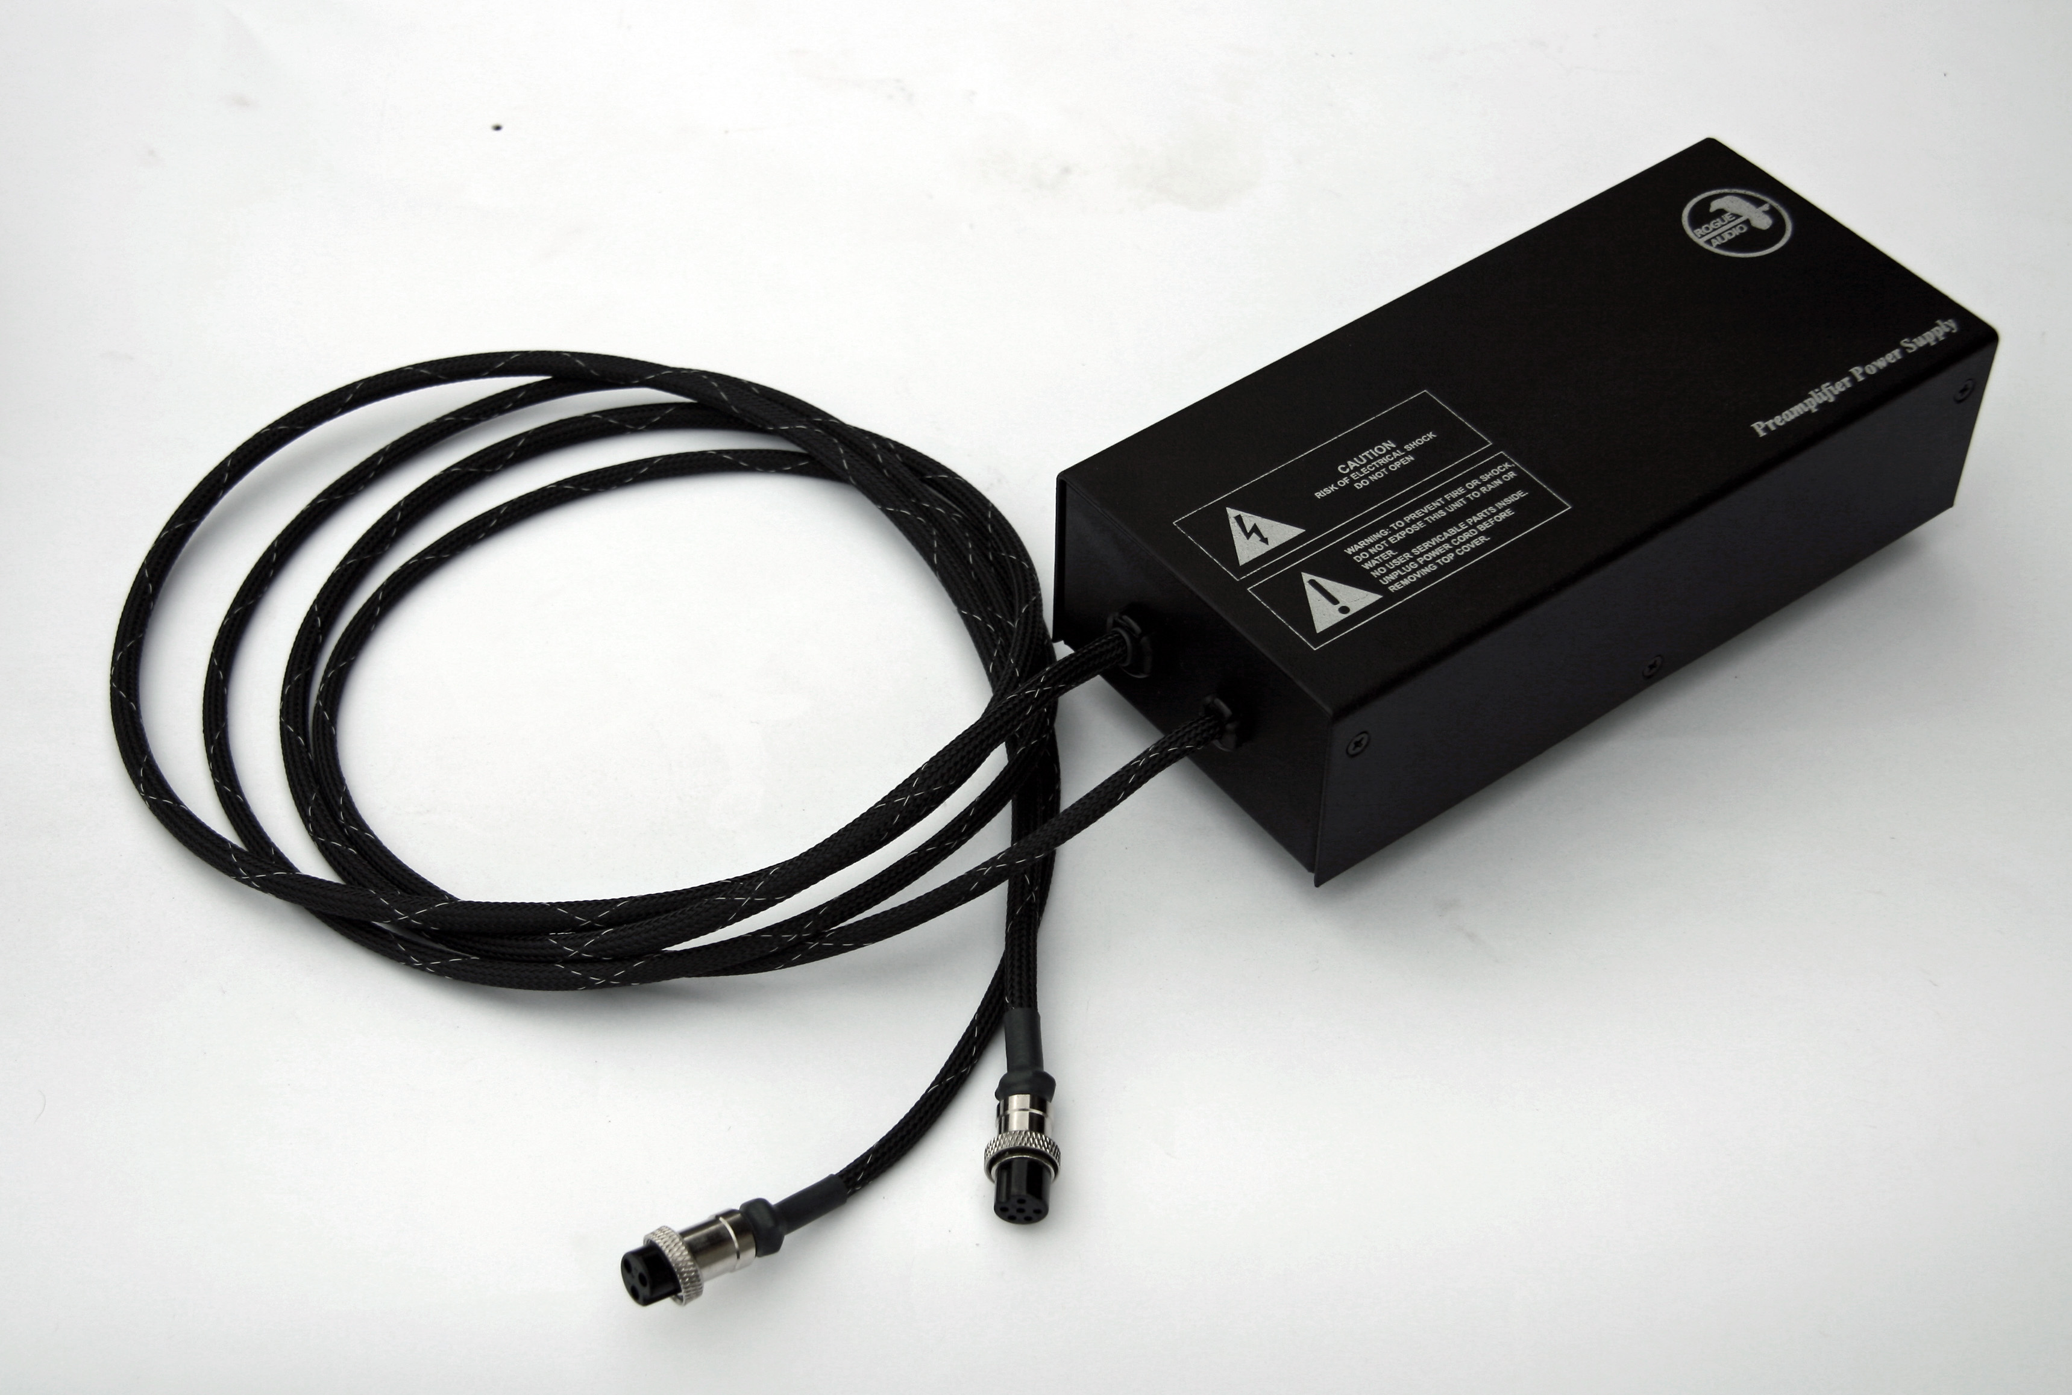
Figure 2

Connecting the Ares power supply to the power outlet:
Connect the IEC end of the detachable power cord to the power supply and plug the opposite end of the power cord into an appropriate power outlet. It is recommended that all components are plugged into the same wall outlet if possible (perhaps using a power outlet strip) in order to avoid creating a ground loop.

outputs to preamp
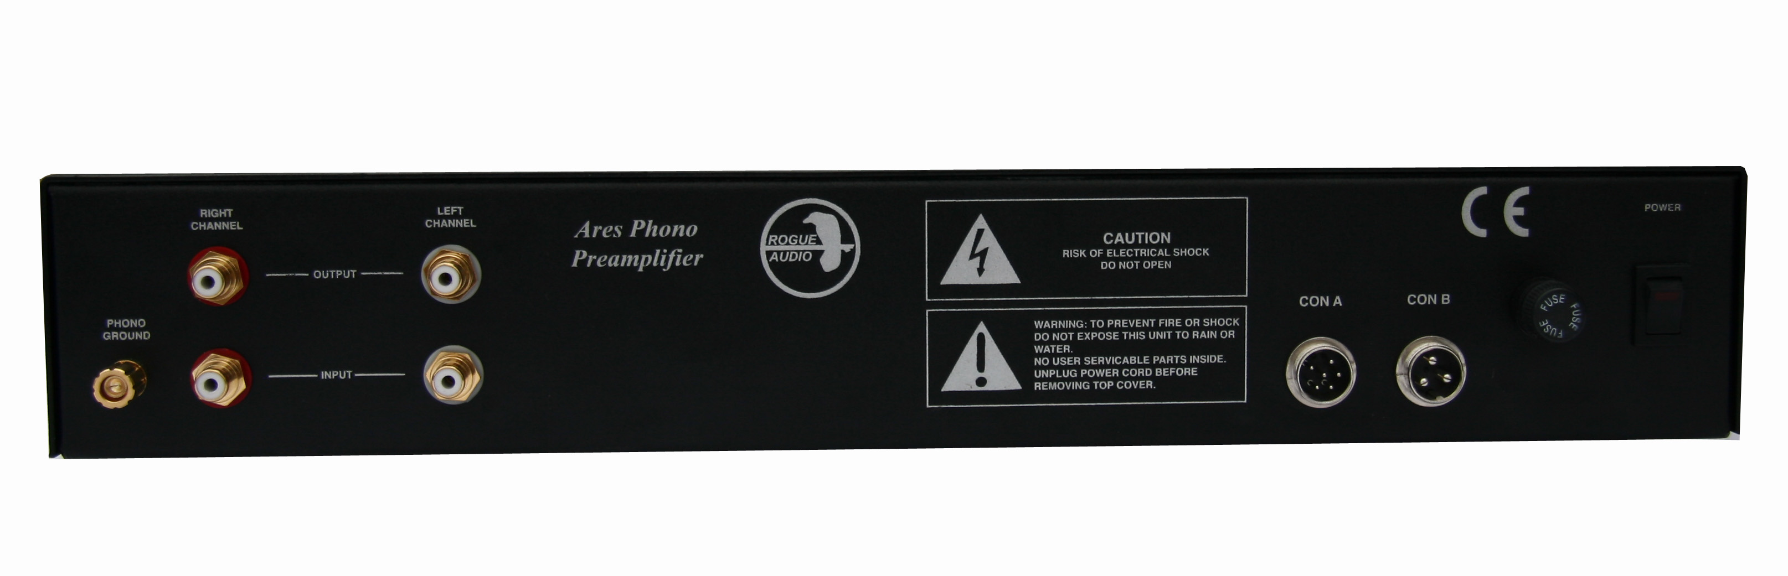

Figure 3
turntable leads
grounding lug con A con B power on/off

Connecting the Ares to your preamp and turntable:
Connections are made on the rear panel of the Ares as shown in Figure 3. The lower pair of RCA jacks connect to the turntable leads and the upper pair are the outputs to your preamp. The red jacks are the right channel and the white jacks are the left channel.

SETTING THE ARES OPERATING PARAMETERS

The Ares is an extremely flexible phono preamp that is compatible with almost all popular cartridges. All of the adjustments can be made through the access panel on the top of the unit. While the number of switches may at first appear daunting, setting up the Ares is actually quite simple. Figure 4 shows the different switches for setting up the Ares. There are three different gain levels and five different resistive cartridge loads that are available. There is also 150pF that can be added for certain cartridge types that require it.

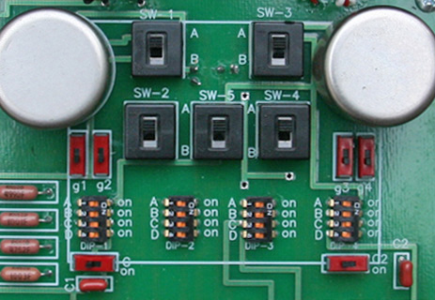

Figure 4

The details of how to set the phono preamp up for various cartridges will follow but briefly, the switches are used as follows:
Switches SW1 through SW-5 set the gain of the Ares
DIP switches DIP-1 through DIP-4 are for the cartridge loading
The four switches g1 through g-4 are for the preamp grounding
Switches C1 and C2 allow a small amount of capacitance to be added for certain cartridge types.

When we talk about switch positions we will use the following conventions:
Forward is toward the front (faceplate side) of the Ares and rear is towards the back (connection side) of the Ares. Left and right are with respect to the front (the faceplate side) of the Ares. Looking at figure 4, SW1 through SW-5 are all in the rear position and Switches g1 through g4 are all in the forward position. Switches C1 and C2 are towards the left.

All setup should be done with the Ares turned off (power switch in the off position). Loud scary and possibly damaging noises can be created with this very high gain phono section.

Warning – Never make any changes to the Ares gain switches or loading switches while the unit is powered. Always turn the Ares off before making any changes.

Setup for high output MM and MC cartridges

Figure 5 shows the basic switch positions for high output cartridges.

Figure 5

Dip-1 Dip-4

Switches SW1, SW2, SW3, SW4 and SW-5 should all be switched to the rear.
Dip –1 and Dip-4 are used to set the cartridge loading according to the following table:
A | 500 ohms
B | 1,000 ohms (1K)
C | 47,000 ohms (47K)
D | 100,000 ohms (100K)
None | 1,000,000 (1 Meg)

To select the desired loading, slide the appropriate DIP switch over towards the right side (the “on” position). DIP-1 is for the left channel and DIP-4 is for the right channel.

If your cartridge specifically requires some capacitance to ground, slide the two small red switches labeled C1 and C2 over to the right side position. Otherwise, leave them to the left for best performance.

Most higher output cartridges will use the 47K loading.

Setup for medium output (0.5mV to 1.0mV) MC cartridges

Figure 6 shows the basic switch positions for medium output cartridges.

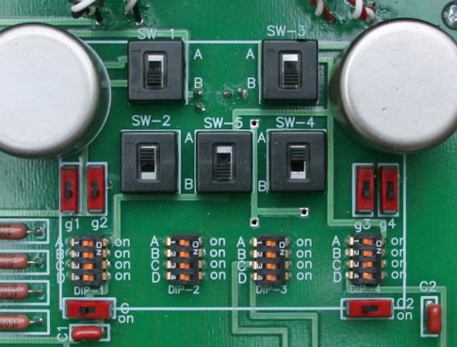

Figure 6

Dip-2 Dip-3

Switches SW1, SW3, and SW-5 should all be switched to the forward position. Switches SW2 and SW4 should be switched toward the rear as shown in figure 6.
Dip –2 and Dip-3 are used to set the cartridge loading according to the following table:
A | 75 ohms
B | 150 ohms
C | 300 ohms
D | 1,000 ohms (1K)
None | 2,500 ohms (2.5K)

To select the desired loading, slide the appropriate DIP switch over towards the right side (the “on” position). DIP-2 is for the left channel and DIP-3 is for the right channel. Figure 5 shows Dip-2 and DIP-3 in the 2.5K ohms “None” position.

Many medium output cartridges will use the 150 ohm “B” setting which is a good place to start.

Setup for low output (less than 0.5mV) MC cartridges

Figure 7 shows the basic switch positions for low output cartridges.

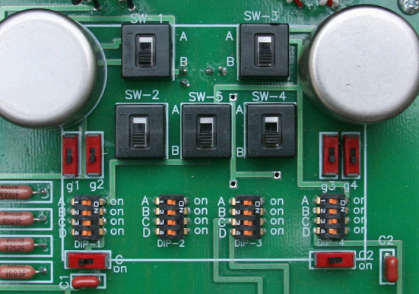

Figure 7

Dip-2 Dip-3

Switches SW1, SW2,SW3, SW4 and SW-5 should all be switched to the forward position as shown in figure 7.
Dip –2 and Dip-3 are used to set the cartridge loading according to the following table:
A | 20 ohms
B | 50 ohms
C | 100 ohms
D | 300 ohms
None | 1,100 ohms (1.1K)

To select the desired loading, slide the appropriate DIP switch over towards the right side (the “on” position). DIP-2 is for the left channel and DIP-3 is for the right channel. Figure 5 shows Dip-2 and DIP-3 in the 1.1K ohms “None” position.

Many low output cartridges will use the 50 ohm “B” setting which is a good place to start.

Grounding switches g1 through g4:
The four small grounding switches g1, g2, g3, g4 will most often be set in the forward position as shown in the preceding photographs. If you are experiencing excessive hum you can try moving them in the various possible configurations g1, g3 forward g2, g4 to the rear, etc.. Some cartridges that share internal grounding between channels may require that one channel be grounded while the other is not (e.g. g1, g2 forward and g3, g4 to the rear).

OPERATING THE ARES

Once the Ares has been installed in your system and set up according to your cartridge requirements it is ready to be turned on. The Ares has a timer circuit built into it to minimize turn on thumps and noises. Nonetheless, the Ares should always be turned on before the preamplifier and turned off after the preamplifier has been turned off. The on/off power switch is located on the left rear of the unit. After poweringon the Ares the timer circuit will delay any output for approximately 30 seconds while the tubes warm up and the circuit stabilizes.

Note – The Ares will not ouput any signal for the first 30 seconds of operation while the circuitry is being energized.

The tube circuitry in the Ares is also quite flexible and can accommodate several different tube types. If you find that you would like a bit more gain you can replace the two 12AU7 tubes with 12AT7 or 12AX7 tubes. This may be particularly useful in the case of low output Moving Magnet cartridges.

TROUBLESHOOTING

Excessive hum
- Improper grounding of an outboard phono sections can often result in excessive hum. Since the grounding on every sytem is different, it is impossible to provide a uniform grounding strategy that will work for every system. Be assured that with correct grounding almost all audible hum can be eliminated. If you are experiencing some hum, try the following:

- Be sure to have the Ares plugged into the same outlet or power strip as your preamplifier.
- Connect the turntable ground to the ground lug on the rear of the Ares
- You may need to connect a ground wire from the Ares to your preamplifier.
- Try different combinations of the internal grounding switches g1-g4 under the Ares access panel
Some or all of the above should eliminate most hum. If this fails to cure the hum, call customer service at Rogue Audio for further advice 570-992-9901.

Excessive hiss
- The Ares is an all tube phono with very high gain and it is normal to hear a small amount of hiss when turned up to very high volumes. If you have excessive hiss you may need to replace one or more of the tubes.

Unit does not turn on
- Check that the power cord connection is secure

Unit does not play
- Ensure that the interconnects are connected to the proper input or output.
- Ensure that the interconnects are connected securely.

One channel does not play
- Enssure that the interconnects are connected and making good contact.
- Ensure that the tubes are seated correctly and securely
- Try swapping the tubes from left to right to identify a bad tube.

If further help is needed please call Rogue Audio Technical Support at 570-992-9901.

FUSE VALUES

One 11/4A (1.25A) Slow Blow type fuse located on rear of main chassis.
One 11/4A (1.25A) Slow Blow type fuse located in the outboard power supply.

SPECIFICATIONS

Input tubes | Two 12AX7 tubes
Secondary tubes | Two 12AU7 (others optional)
RIAA | Passive +/- 0.25dB
THD | <0.1%
Rated Output | 1V RMS
Output impedance | 600 Ohms
Maximum Output | 8V RMS @ 1KHz
Main Unit Dimensions | 17” W x 9”D x 5.5”H
Power Supply Dimensions | 9” D x 4.25” W x 3”H
Shipping weight | 20 lb
Power Requirements | 115/230V – 50/60Hz

Owner and Warranty registration form
Included with this manual is an Owner and Warranty Registration Form. Please take a minute to fill out this card and return it to Rogue Audio. This card must be returned within 30 days of purchase to validate the warranty.

Limited Warranty
Warranty Period
This product has been manufactured under the highest standards of quality and workmanship. Rogue Audio Inc. (hereinafter “Rogue Audio”) warrants this product against defects in material or workmanship as follows:
With the exception of vacuum tubes, Rogue Audio warrants to the original purchaser of this product all parts of this product against defects in material and workmanship for a period of three years from the date of retail purchase. Rogue Audio warrants the vacuum tubes for a period of six months from the date of retail purchase. Any defective parts will be replaced free of charge, excluding shipping and handling.
Proof of purchase in the form of a bill of sale or recited invoice which indicates that the product is within the warranty period must be presented to obtain warranty service. Rogue Audio suggests that the purchaser retain the dealer’s bill of sale as evidence of the date of retail purchase.

What’s Not Covered
This warranty does not cover cosmetic damage or any damage that results from product misuse, product abuse, installation error, connection to an improper voltage supply, accident, improper maintenance, alterations, modifications not authorized in writing by Rogue Audio, lightening, power surges, or acts of God. Use of any other than Rogue Audio factory parts may void this warranty.
This warranty does not cover the cost of parts and labor which would be otherwise provided without charge under this warranty, obtained from any source other than Rogue Audio.
This warranty applies only to consumer use of this product and does not cover any product that is used in any trade or business, or in an industrial or commercial application.
This warranty applies only to the original purchaser of this product when purchased from an Authorized Rogue Audio dealer.
This warranty is valid only in the United States.
YOUR RIGHTS
Rogue Audio limits its obligations under any implied warranties under state laws to a period not to exceed the warranty period. Some states do not allow limitations on how long an implied warranty lasts, and some states do not allow the exclusion or limitation of incidental or consequential damages, so the above limitations or exclusions may not apply to you. This warranty gives you specific legal rights, and you may have other rights which may vary from state to state.

To Obtain Service
To obtain service, you must contact Rogue Audio and obtain a return authorization number. The product must be delivered to Rogue Audio in its original packaging prepaid at the following address:

Rogue Audio Inc.

3 Marian Lane
Brodheadsville, PA 18322

